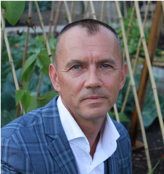

Tim Knight

*CEO*

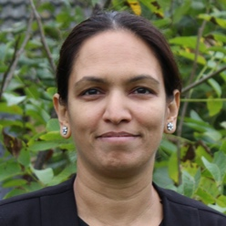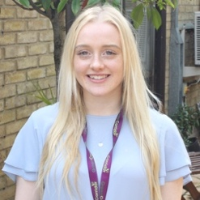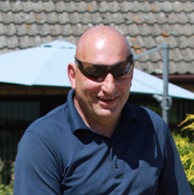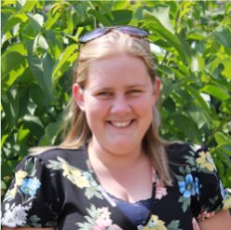

Briony Williams

*Marketing & HR Officer*

v

Mandeep Gill

*Careers, Information & Guidance Officer*

Mark Cox

*Head of Project Delivery*

Sophie Rolfe

*Director of Education*

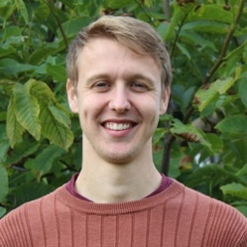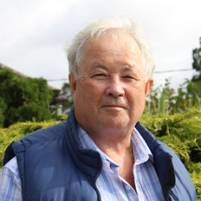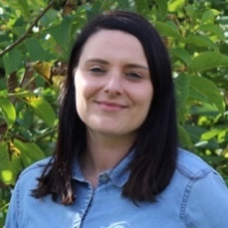

Luke Cairns

*Functional Skills Tutor*

Agnieszka Biskup

*Cleaner*

Tim Whitelaw

*Head of Functional Skills*

David Parsons

*Minibus Driver*

Peter Fieldwick

*Head of Horticulture*

Hayley Harris

*EHCP Coordinator*

Tracey Palmer-Hall

*Head of Catering*

Yasmin Denham

*Admin Officer*

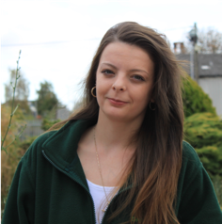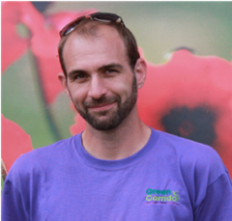

Jasmine Wilfort

*Teaching Assistant*

Chelsea Young

*Teaching Assistant*

Hannah Yetman

*Teaching Assistant*

Theodore Bouras

*Catering Tutor*

(TBC)

*Teaching Assistant*

Shaun Hall

*Teaching Assistant*

Collin Cakebread

*Horticulture Tutor*

Karen Innes

*Higher Level Teaching Assistant*

Alfie Young

*Teaching Assistant*

Sam Congreve

*Horticulture Tutor*

Alisha Dhanda

*Teaching Assistant*

Eric Freestone

*Horticulture Tutor*

Matt Wheeler

*Teaching Assistant*

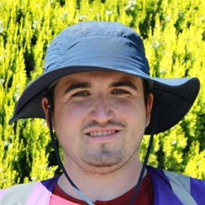

Dean Lyons

*Kitchen Gardener*

Thomas Urry

*Teaching Assistant*