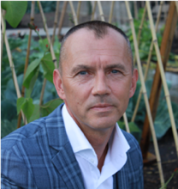

Tim Knight

*CEO*



Dawn Mowbray

*Careers Advisor*

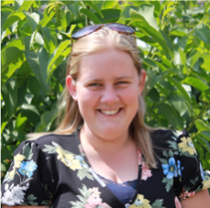

Sophie Rolfe

*Head of Education*



TBC (July 2022)

*ESFA*

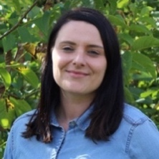

Hayley Harris

*SENCo*



Mark Cox

*Head of Project Delivery*

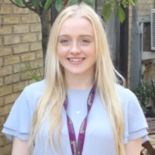

Briony Williams

*HR & Marketing*



Ben Glazier

*Therapy Assistant*



Peter Fieldwick

*Head of Horticulture*

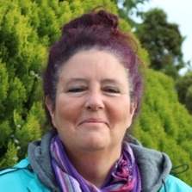

Samantha Congreve

*Horticulture Tutor*



Eric Freestone

*Horticulture Tutor*



TBC

*Horticulture Tutor*



Tim Whitelaw

*Head of Functional Skills*



Luke Cairns

*Functional Skills Tutor*



Emma Peel

*Functional Skills Tutor*

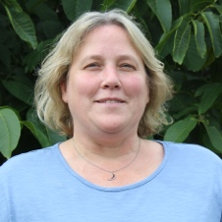

TBC

*Functional Skills Tutor*



Claire Taylor

*Job Coach*

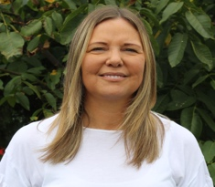

Lauren Fraser

*Admin Officer*



Agnieszka Biskup

*Cleaner*

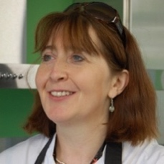

Tracey Palmer-Hall

*Head of Catering*



Sadie Dallas

*Admin Officer*

Steven Allen

*Minibus Driver*



Brenda Heron

*SALT*

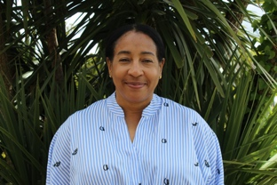



TBC

*Life Skills Tutor*



James Huntley

*HLTA*

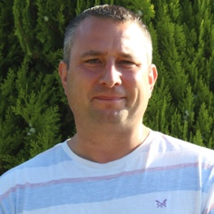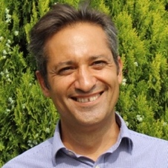

Theo Bouras

*Catering Tutor*

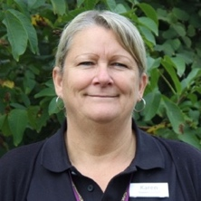

Karen Innes

*HLTA*

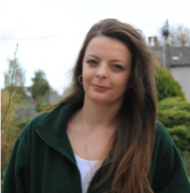

Chelsea Young

*Family Link Worker*

Janita Dingwall

*Occupational Therapist*



Alisha Dhanda

*Teaching Assistant*



Joshua Menke

*Catering Tutor*

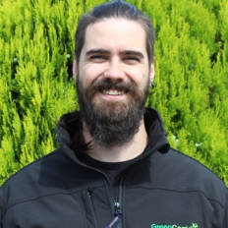

Alfie Young

*Teaching Assistant*



Jade Doyle

*Teaching Assistant*

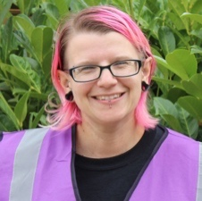

Rachell Peters

*Teaching Assistant*

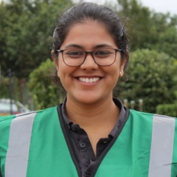

Michael Nunez

*Teaching Assistant*



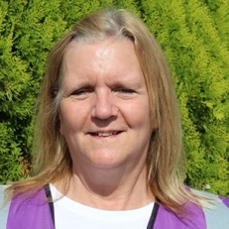



Elaine Barlow

*Teaching Assistant*



Ionut (John) Mistretu

*Catering Manager*

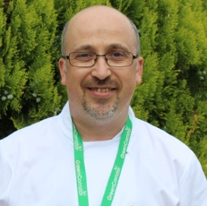

Sharon Bayford

*Teaching Assistant*

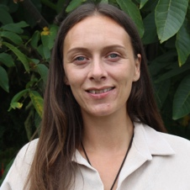



Sarah Perks

*Teaching Assistant*



Harpreet Kaur

*Teaching Assistant*



George Palmer-Hall

*Teaching Assistant*

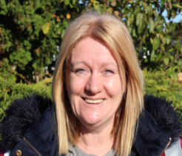



TBC

*Teaching Assistant*



TBC

*Teaching Assistant*



Cian Simmons

*Teaching Assistant*



TBC

*Teaching Assistant*



TBC

*Teaching Assistant*



Louise Bessell

*Teaching Assistant*

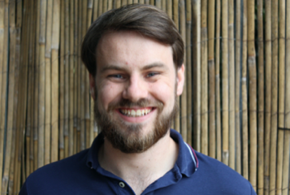

Thomas Urry

*Teaching Assistant*



Megan Avery

*Teaching Assistant*

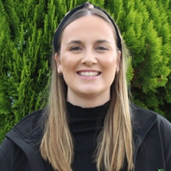

Simon Hilton

*Teaching Assistant*